EXNO:1

import javax.swing.*;
import javax.swing.table.DefaultTableModel;
import java.awt.*;
import java.awt.event.*;
import java.sql.*;
public class StudentCRUDApp extends JFrame {
private static final String URL = "jdbc:mysql://localhost:3306/testdb";
private static final String USER = "root";
private static final String PASS = "12345";
private JTextField txtId, txtName, txtDept;
private JTable table;
private DefaultTableModel model;
private Connection con;
public StudentCRUDApp() {
setTitle("Student Management System");
setSize(700, 500);
setDefaultCloseOperation(EXIT_ON_CLOSE);
setLayout(new BorderLayout());
connectDB()
JPanel panel = new JPanel(new GridLayout(4, 2, 10, 10));
panel.add(new JLabel("ID"));
txtId = new JTextField();
panel.add(txtId);
panel.add(new JLabel("Name"));
txtName = new JTextField();
panel.add(txtName);
panel.add(new JLabel("Department"));
txtDept = new JTextField();
panel.add(txtDept);
JButton btnAdd = new JButton("Add");
JButton btnUpdate = new JButton("Update");
panel.add(btnAdd);
panel.add(btnUpdate);
add(panel, BorderLayout.NORTH);
model = new DefaultTableModel(new String[]{"ID", "Name", "Department"}, 0);
table = new JTable(model);
add(new JScrollPane(table), BorderLayout.CENTER);
JPanel bottom = new JPanel();
JButton btnDelete = new JButton("Delete");
JButton btnClear = new JButton("Clear");
bottom.add(btnDelete);
bottom.add(btnClear);
add(bottom, BorderLayout.SOUTH);
loadData();
btnAdd.addActionListener(e -> addStudent());
btnUpdate.addActionListener(e -> updateStudent());
btnDelete.addActionListener(e -> deleteStudent());
btnClear.addActionListener(e -> clearFields());
table.addMouseListener(new MouseAdapter() {
public void mouseClicked(MouseEvent e) {
int row = table.getSelectedRow();
txtId.setText(model.getValueAt(row, 0).toString());
txtName.setText(model.getValueAt(row, 1).toString());
txtDept.setText(model.getValueAt(row, 2).toString());
}
});
}
private void connectDB() {
try {
Class.forName("com.mysql.cj.jdbc.Driver");
con = DriverManager.getConnection(URL, USER, PASS);
} catch (Exception e) {
JOptionPane.showMessageDialog(this, "DB Error: " + e.getMessage());
}
}
private void loadData() {
model.setRowCount(0);
try {
Statement st = con.createStatement();
ResultSet rs = st.executeQuery("SELECT * FROM students");
while (rs.next()) {
model.addRow(new Object[]{
rs.getInt("id"),
rs.getString("name"),
rs.getString("department")
});
}
} catch (Exception e) {
JOptionPane.showMessageDialog(this, e.getMessage());
}
}
private void addStudent() {
try {
PreparedStatement ps = con.prepareStatement(
"INSERT INTO students VALUES (?, ?, ?)"
);
ps.setInt(1, Integer.parseInt(txtId.getText()));
ps.setString(2, txtName.getText());
ps.setString(3, txtDept.getText());
ps.executeUpdate();
JOptionPane.showMessageDialog(this, "Added!");
loadData();
clearFields();
} catch (Exception e) {
JOptionPane.showMessageDialog(this, e.getMessage());
}
}

private void updateStudent() {
try {
PreparedStatement ps = con.prepareStatement(
"UPDATE students SET name=?, department=? WHERE id=?"
);
ps.setString(1, txtName.getText());
ps.setString(2, txtDept.getText());
ps.setInt(3, Integer.parseInt(txtId.getText()));
ps.executeUpdate();

JOptionPane.showMessageDialog(this, "Updated!");
loadData();
clearFields();
} catch (Exception e) {
JOptionPane.showMessageDialog(this, e.getMessage());
}
}

private void deleteStudent() {
try {
PreparedStatement ps = con.prepareStatement(
"DELETE FROM students WHERE id=?"
);
ps.setInt(1, Integer.parseInt(txtId.getText()));
ps.executeUpdate();

JOptionPane.showMessageDialog(this, "Deleted!");
loadData();
clearFields();
} catch (Exception e) {
JOptionPane.showMessageDialog(this, e.getMessage());
}
}

private void clearFields() {
txtId.setText("");
txtName.setText("");
txtDept.setText("");
}

public static void main(String[] args) {
SwingUtilities.invokeLater(() -> {
new StudentCRUDApp().setVisible(true);
});
}
}

OUTPUT:

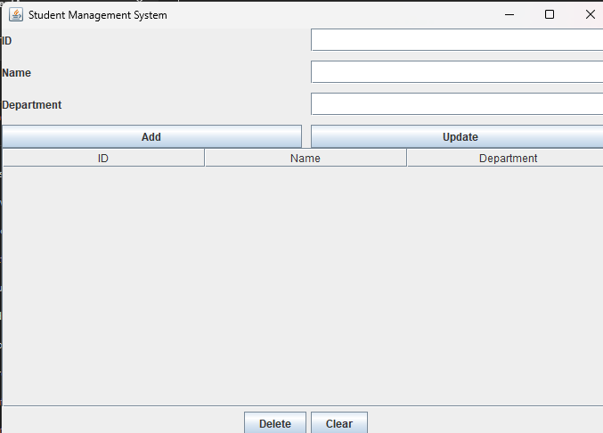

EXNO:2

import javax.swing.*;
import java.awt.*;
import java.awt.event.*;
import java.io.*;
public class NotepadApp extends JFrame implements ActionListener {
JTextArea textArea;
JMenuBar menuBar;
JMenu fileMenu, editMenu;
JMenuItem newFile, openFile, saveFile, saveAsFile, exit;
JMenuItem cut, copy, paste, selectAll;
JFileChooser fileChooser;
File currentFile = null;
public NotepadApp() {
setTitle("Simple Notepad");
setSize(700, 500);
setDefaultCloseOperation(EXIT_ON_CLOSE);
textArea = new JTextArea();
JScrollPane scrollPane = new JScrollPane(textArea);
add(scrollPane);
menuBar = new JMenuBar();
fileMenu = new JMenu("File");
newFile = new JMenuItem("New");
openFile = new JMenuItem("Open");
saveFile = new JMenuItem("Save");
saveAsFile = new JMenuItem("Save As");
exit = new JMenuItem("Exit");
editMenu = new JMenu("Edit");
cut = new JMenuItem("Cut");
copy = new JMenuItem("Copy");
paste = new JMenuItem("Paste");
selectAll = new JMenuItem("Select All");
newFile.addActionListener(this);
openFile.addActionListener(this);
saveFile.addActionListener(this);
saveAsFile.addActionListener(this);
exit.addActionListener(this);
cut.addActionListener(this);
copy.addActionListener(this);
paste.addActionListener(this);
selectAll.addActionListener(this);
fileMenu.add(newFile);
fileMenu.add(openFile);
fileMenu.add(saveFile);
fileMenu.add(saveAsFile);
fileMenu.addSeparator();
fileMenu.add(exit);
editMenu.add(cut);
editMenu.add(copy);
editMenu.add(paste);
editMenu.add(selectAll);
menuBar.add(fileMenu);
menuBar.add(editMenu);
setJMenuBar(menuBar);
fileChooser = new JFileChooser();
setVisible(true);
}
public void actionPerformed(ActionEvent e) {
if (e.getSource() == newFile) {
textArea.setText("");
currentFile = null;
setTitle("Simple Notepad");
}
else if (e.getSource() == openFile) {
int option = fileChooser.showOpenDialog(this);
if (option == JFileChooser.APPROVE_OPTION) {
currentFile = fileChooser.getSelectedFile();
try (BufferedReader reader = new BufferedReader(new FileReader(currentFile))) {
textArea.read(reader, null);
setTitle(currentFile.getName());
} catch (IOException ex) {
JOptionPane.showMessageDialog(this, "Error opening file");
}
}
}
else if (e.getSource() == saveFile) {
if (currentFile != null) {
saveToFile(currentFile);
} else {
saveAsFile.doClick();
}
}
else if (e.getSource() == saveAsFile) {
int option = fileChooser.showSaveDialog(this);
if (option == JFileChooser.APPROVE_OPTION) {
currentFile = fileChooser.getSelectedFile();
saveToFile(currentFile);
setTitle(currentFile.getName());
}
}
else if (e.getSource() == exit) {
System.exit(0);
}
else if (e.getSource() == cut) {
textArea.cut();
} else if (e.getSource() == copy) {
textArea.copy();
} else if (e.getSource() == paste) {
textArea.paste();
} else if (e.getSource() == selectAll) {
textArea.selectAll();
}
}
private void saveToFile(File file) {
try (BufferedWriter writer = new BufferedWriter(new FileWriter(file))) {
textArea.write(writer);
} catch (IOException ex) {
JOptionPane.showMessageDialog(this, "Error saving file");
}
}
public static void main(String[] args) {
new NotepadApp();
}
}

OUTPUT:

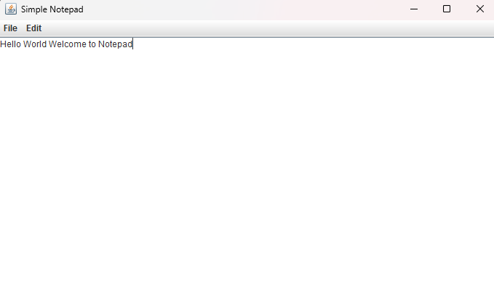

EXNO:3

import javax.swing.*;
import java.awt.*;
import java.awt.event.*;
public class InterestCalculator extends JFrame implements ActionListener {
JTextField principalField, rateField, timeField, resultField;
JButton simpleBtn, compoundBtn, clearBtn;
public InterestCalculator() {
setTitle("Interest Calculator");
setSize(400, 300);
setDefaultCloseOperation(EXIT_ON_CLOSE);
setLayout(new GridLayout(6, 2, 10, 10));
add(new JLabel("Principal Amount:"));
principalField = new JTextField();
add(principalField);
add(new JLabel("Rate (%):"));
rateField = new JTextField();
add(rateField);
add(new JLabel("Time (years):"));
timeField = new JTextField();
add(timeField);
add(new JLabel("Result:"));
resultField = new JTextField();
resultField.setEditable(false);
add(resultField);
simpleBtn = new JButton("Simple Interest");
compoundBtn = new JButton("Compound Interest");
clearBtn = new JButton("Clear");
add(simpleBtn);
add(compoundBtn);
add(clearBtn);
simpleBtn.addActionListener(this);
compoundBtn.addActionListener(this);
clearBtn.addActionListener(this);
setVisible(true);
}
public void actionPerformed(ActionEvent e) {
try {
double p = Double.parseDouble(principalField.getText());
double r = Double.parseDouble(rateField.getText());
double t = Double.parseDouble(timeField.getText());
if (e.getSource() == simpleBtn) {
double si = (p * r * t) / 100;
resultField.setText(String.valueOf(si));
}
else if (e.getSource() == compoundBtn) {
double ci = p * Math.pow((1 + r / 100), t) - p;
resultField.setText(String.valueOf(ci));
}
else if (e.getSource() == clearBtn) {
principalField.setText("");
rateField.setText("");
timeField.setText("");
resultField.setText("");
}
} catch (NumberFormatException ex) {
JOptionPane.showMessageDialog(this, "Please enter valid numbers!");
}
}
public static void main(String[] args) {
SwingUtilities.invokeLater(() -> new InterestCalculator());
}
}

OUTPUT:

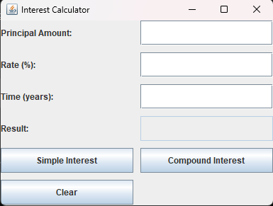

EXNO:4

Package com.auth;

import java.sql.Connection;
import java.sql.DriverManager;
import java.sql.SQLException;
public class DBConnection {
private static final String URL = "jdbc:mysql://127.0.0.1:3306/userauthdb?useSSL=false&allowPublicKeyRetrieval=true&serverTimezone=UTC";
private static final String USER = "root";
private static final String PASSWORD = "12345";

public static Connection getConnection() {
try {
Class.forName("com.mysql.cj.jdbc.Driver");
return DriverManager.getConnection(URL, USER, PASSWORD);
} catch (ClassNotFoundException e) {
System.err.println("JDBC Driver not found: " + e.getMessage());
e.printStackTrace();
return null;
} catch (SQLException e) {
System.err.println("JDBC connection failed: " + e.getMessage());
e.printStackTrace();
return null;
}
}
}

Login page

Package com.auth;

import java.io.IOException;
import java.io.PrintWriter;
import java.sql.Connection;
import java.sql.PreparedStatement;
import java.sql.ResultSet;

import jakarta.servlet.ServletException;
import jakarta.servlet.http.HttpServlet;
import jakarta.servlet.http.HttpServletRequest;
import jakarta.servlet.http.HttpServletResponse;
import jakarta.servlet.http.HttpSession;

public class LoginServlet extends HttpServlet {

protected void doPost(HttpServletRequest request, HttpServletResponse response)
throws ServletException, IOException {

response.setContentType("text/html");
PrintWriter out = response.getWriter();

String email = request.getParameter("email");
String password = request.getParameter("password");

try (Connection con = DBConnection.getConnection()) {
if (con == null) {
out.println("<h2>Database connection failed.</h2>");
out.println("<a href='login.html'>Back</a>");
return;
}

String query = "SELECT * FROM users WHERE email=? AND password=?";

try (PreparedStatement ps = con.prepareStatement(query)) {
ps.setString(1, email);
ps.setString(2, password);

try (ResultSet rs = ps.executeQuery()) {
if (rs.next()) {
HttpSession session = request.getSession();

session.setAttribute("name", rs.getString("name"));
session.setAttribute("email", rs.getString("email"));
session.setAttribute("city", rs.getString("city"));

response.sendRedirect("welcome.jsp");
} else {
out.println("<h2>Invalid Email or Password!</h2>");
out.println("<a href='login.html'>Try Again</a>");
}
}
}

} catch (Exception e) {
e.printStackTrace();
out.println("<h2>Error: " + e.getMessage() + "</h2>");
out.println("<a href='login.html'>Back</a>");
}
}
}
Logout Page

package com.auth;

import java.io.IOException;

import jakarta.servlet.ServletException;
import jakarta.servlet.http.HttpServlet;
import jakarta.servlet.http.HttpServletRequest;
import jakarta.servlet.http.HttpServletResponse;
import jakarta.servlet.http.HttpSession;

public class LogoutServlet extends HttpServlet {

protected void doGet(HttpServletRequest request, HttpServletResponse response)
throws ServletException, IOException {

HttpSession session = request.getSession(false);

if (session != null) {
session.invalidate();
}

response.sendRedirect("login.html");
}
}

Registration page

package com.auth;

import java.io.IOException;
import java.io.PrintWriter;
import java.sql.Connection;
import java.sql.PreparedStatement;

import jakarta.servlet.ServletException;
import jakarta.servlet.http.HttpServlet;
import jakarta.servlet.http.HttpServletRequest;
import jakarta.servlet.http.HttpServletResponse;

public class RegisterServlet extends HttpServlet {

protected void doPost(HttpServletRequest request, HttpServletResponse response)
throws ServletException, IOException {

response.setContentType("text/html");
PrintWriter out = response.getWriter();

String name = request.getParameter("name");
String email = request.getParameter("email");
String password = request.getParameter("password");
String city = request.getParameter("city");

try (Connection con = DBConnection.getConnection()) {
if (con == null) {
out.println("<h2>Database connection failed.</h2>");
out.println("<a href='register.html'>Back</a>");
return;
}

String query = "INSERT INTO users(name, email, password, city) VALUES (?, ?, ?, ?)";

try (PreparedStatement ps = con.prepareStatement(query)) {
ps.setString(1, name);
ps.setString(2, email);
ps.setString(3, password);
ps.setString(4, city);

int result = ps.executeUpdate();

if (result > 0) {
out.println("<h2>Registration Successful!</h2>");
out.println("<a href='login.html'>Click here to Login</a>");
} else {
out.println("<h2>Registration Failed!</h2>");
out.println("<a href='register.html'>Try Again</a>");
}
}

} catch (Exception e) {
e.printStackTrace();
out.println("<h2>Error: " + e.getMessage() + "</h2>");
out.println("<a href='register.html'>Back</a>");
}
}
}

OUTPUT:

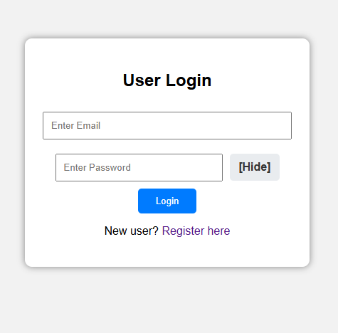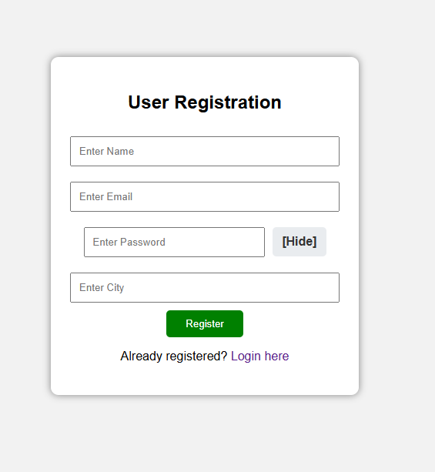

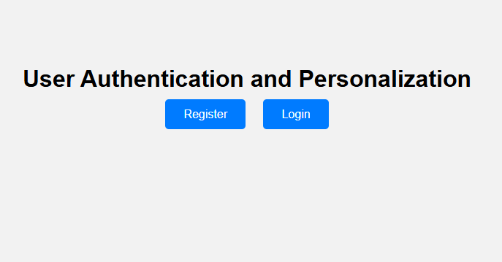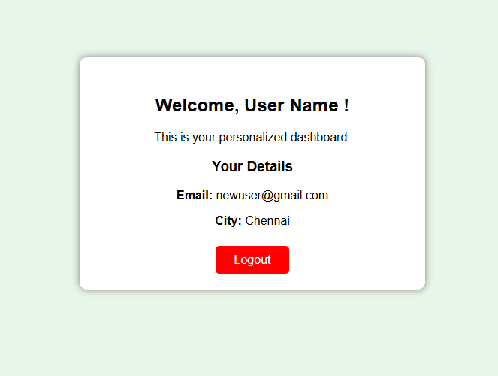

EXNO:5

package dao;

import java.sql.Connection;
import java.sql.DriverManager;
import java.sql.SQLException;
import java.util.logging.Level;
import java.util.logging.Logger;
public class DBConnection {
private static final Logger LOGGER = Logger.getLogger(DBConnection.class.getName());
public static Connection getConnection() {
try {
Class.forName("com.mysql.cj.jdbc.Driver");

Connection con = DriverManager.getConnection(
"jdbc:mysql://localhost:3306/shopping",
"root",
"12345"
);
LOGGER.info("DB connected successfully");
return con;
} catch (ClassNotFoundException | SQLException e) {
LOGGER.log(Level.SEVERE, "DB connection failed", e);
return null;
}
}
}

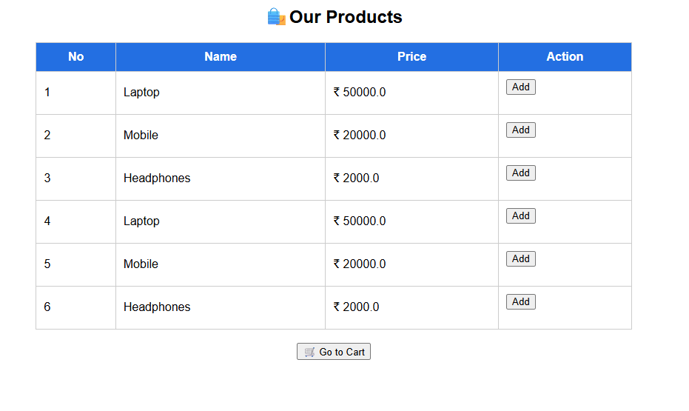

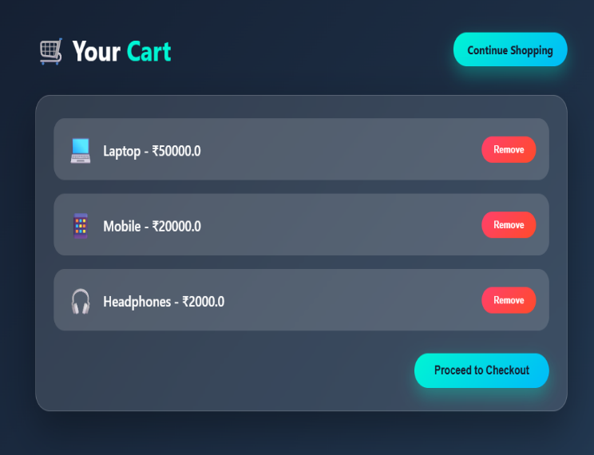

EXNO:6

<?xml version="1.0" encoding="UTF-8"?>

<web-app xmlns="https://jakarta.ee/xml/ns/jakartaee"
xmlns:xsi="http://www.w3.org/2001/XMLSchema-instance"
xsi:schemaLocation="https://jakarta.ee/xml/ns/jakartaee
https://jakarta.ee/xml/ns/jakartaee/web-app_5_0.xsd"
version="5.0">

<welcome-file-list>
<welcome-file>index.jsp</welcome-file>
</welcome-file-list>

</web-app>

OUTPUT:

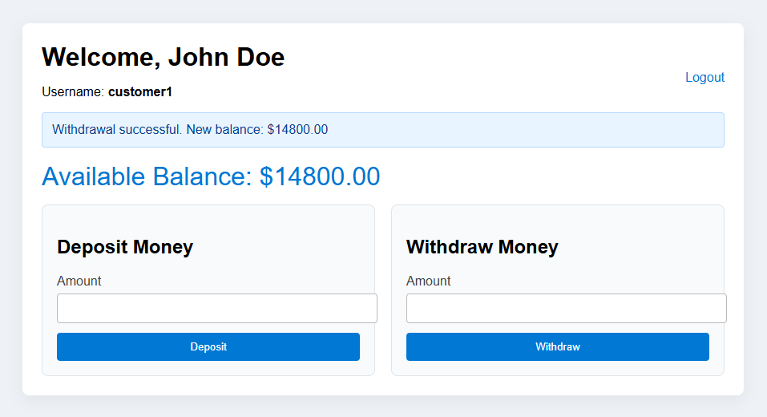

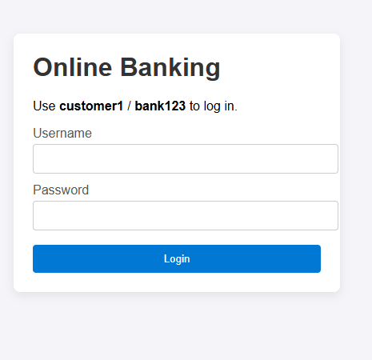

EXNO:7

package com.studentapp.controller;

import com.studentapp.dao.StudentDAO;
import com.studentapp.model.Student;

import jakarta.servlet.RequestDispatcher;
import jakarta.servlet.ServletException;
import jakarta.servlet.http.HttpServlet;
import jakarta.servlet.http.HttpServletRequest;
import jakarta.servlet.http.HttpServletResponse;
import java.io.IOException;
import java.sql.SQLException;
import java.util.List;

public class StudentController extends HttpServlet {
private static final long serialVersionUID = 1L;
private StudentDAO dao;

@Override
public void init() {
dao = new StudentDAO();
}

@Override
protected void doGet(HttpServletRequest request, HttpServletResponse response) throws ServletException, IOException {
String action = request.getParameter("action");
if (action == null) {
action = "list";
}

try {
switch (action) {
case "new":
showForm(request, response, new Student(), "Create Student", "create");
break;
case "edit":
showEditForm(request, response);
break;
case "delete":
deleteStudent(request, response);
break;
default:
listStudents(request, response);
break;
}
} catch (SQLException e) {
throw new ServletException(e);
}
}

@Override
protected void doPost(HttpServletRequest request, HttpServletResponse response) throws ServletException, IOException {
String action = request.getParameter("action");
try {
if ("create".equals(action)) {
createStudent(request, response);
} else if ("update".equals(action)) {
updateStudent(request, response);
} else {
response.sendRedirect(request.getContextPath() + "/students");
}
} catch (SQLException e) {
throw new ServletException(e);
}
}

private void listStudents(HttpServletRequest request, HttpServletResponse response) throws SQLException, ServletException, IOException {
List<Student> students = dao.listAll();
request.setAttribute("students", students);
RequestDispatcher dispatcher = request.getRequestDispatcher("students.jsp");
dispatcher.forward(request, response);
}

private void showForm(HttpServletRequest request, HttpServletResponse response, Student student, String title, String action) throws ServletException, IOException {
request.setAttribute("student", student);
request.setAttribute("formTitle", title);
request.setAttribute("formAction", action);
RequestDispatcher dispatcher = request.getRequestDispatcher("student-form.jsp");
dispatcher.forward(request, response);
}

private void showEditForm(HttpServletRequest request, HttpServletResponse response) throws SQLException, ServletException, IOException {
int id = Integer.parseInt(request.getParameter("id"));
Student existing = dao.getById(id);
if (existing == null) {
response.sendRedirect(request.getContextPath() + "/students");
return;
}
showForm(request, response, existing, "Edit Student", "update");
}
private void createStudent(HttpServletRequest request, HttpServletResponse response) throws SQLException, IOException {
Student student = new Student();
student.setId(Integer.parseInt(request.getParameter("id")));
student.setName(request.getParameter("name"));
student.setDepartment(request.getParameter("department"));
student.setEmail(request.getParameter("email"));
dao.addStudent(student);
response.sendRedirect(request.getContextPath() + "/students");
}
private void updateStudent(HttpServletRequest request, HttpServletResponse response) throws SQLException, IOException {
Student student = new Student();
student.setId(Integer.parseInt(request.getParameter("id")));
student.setName(request.getParameter("name"));
student.setDepartment(request.getParameter("department"));
student.setEmail(request.getParameter("email"));
dao.updateStudent(student);
response.sendRedirect(request.getContextPath() + "/students");
}
private void deleteStudent(HttpServletRequest request, HttpServletResponse response) throws SQLException, IOException {
int id = Integer.parseInt(request.getParameter("id"));
dao.deleteStudent(id);
response.sendRedirect(request.getContextPath() + "/students");
}
}

OUTPUT:

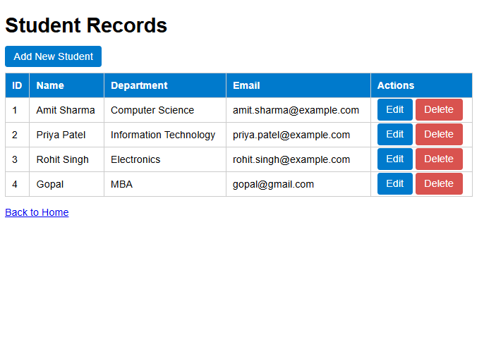

EXNO:8

package com.examapp.controller;

import com.examapp.dao.QuestionDAO;
import com.examapp.model.Question;

import jakarta.servlet.ServletException;
import jakarta.servlet.annotation.WebServlet;
import jakarta.servlet.http.HttpServlet;
import jakarta.servlet.http.HttpServletRequest;
import jakarta.servlet.http.HttpServletResponse;
import java.io.IOException;
import java.sql.SQLException;
import java.util.List;
public class ExamController extends HttpServlet {
private static final long serialVersionUID = 1L;
@Override
protected void doGet(HttpServletRequest request, HttpServletResponse response) throws ServletException, IOException {
try {
List<Question> questions = QuestionDAO.findAll();
request.setAttribute("questions", questions);
request.getRequestDispatcher("exam.jsp").forward(request, response);
} catch (SQLException e) {
request.setAttribute("error", "Unable to load exam questions: " + e.getMessage());
request.getRequestDispatcher("index.jsp").forward(request, response);
}
}
@Override
protected void doPost(HttpServletRequest request, HttpServletResponse response) throws ServletException, IOException {
try {
List<Question> questions = QuestionDAO.findAll();
int score = 0;
for (Question question : questions) {
String answer = request.getParameter("q_" + question.getId());
question.setUserAnswer(answer);
if (answer != null && answer.equals(question.getCorrectOption())) {
score++;
}
}
int total = questions.size();
boolean passed = total == 0 ? false : score >= Math.ceil(total * 0.6);
request.setAttribute("questions", questions);
request.setAttribute("score", score);
request.setAttribute("total", total);
request.setAttribute("passed", passed);
request.getRequestDispatcher("result.jsp").forward(request, response);
} catch (SQLException e) {
request.setAttribute("error", "Unable to score exam: " + e.getMessage());
request.getRequestDispatcher("index.jsp").forward(request, response);
}
}
}

package com.examapp.dao;

import com.examapp.model.Question;
import com.examapp.util.DBConnection;

import java.sql.Connection;
import java.sql.PreparedStatement;
import java.sql.ResultSet;
import java.sql.SQLException;
import java.util.ArrayList;
import java.util.List;

public class QuestionDAO {
private static final String SELECT_ALL = "SELECT id, text, option_a, option_b, option_c, option_d, correct_option FROM questions ORDER BY id";

public static List<Question> findAll() throws SQLException {
List<Question> questions = new ArrayList<>();
try (Connection connection = DBConnection.getConnection();
PreparedStatement statement = connection.prepareStatement(SELECT_ALL);
ResultSet resultSet = statement.executeQuery()) {

while (resultSet.next()) {
Question question = new Question();
question.setId(resultSet.getInt("id"));
question.setText(resultSet.getString("text"));
question.getOptions().put("A", resultSet.getString("option_a"));
question.getOptions().put("B", resultSet.getString("option_b"));
question.getOptions().put("C", resultSet.getString("option_c"));
question.getOptions().put("D", resultSet.getString("option_d"));
question.setCorrectOption(resultSet.getString("correct_option"));
questions.add(question);
}
}
return questions;
}
}

package com.examapp.model;
import java.io.Serializable;
import java.util.LinkedHashMap;
import java.util.Map;
public class Question implements Serializable {
private int id;
private String text;
private Map<String, String> options = new LinkedHashMap<>();
private String correctOption;
private String userAnswer;
public Question() {
}
public Question(int id, String text, String optionA, String optionB, String optionC, String optionD, String correctOption) {
this.id = id;
this.text = text;
options.put("A", optionA);
options.put("B", optionB);
options.put("C", optionC);
options.put("D", optionD);
this.correctOption = correctOption;
}
public int getId() {
return id;
}
public void setId(int id) {
this.id = id;
}
public String getText() {
return text;
}
public void setText(String text) {
this.text = text;
}
public Map<String, String> getOptions() {
return options;
}
public void setOptions(Map<String, String> options) {
this.options = options;
}
public String getCorrectOption() {
return correctOption;
}

public void setCorrectOption(String correctOption) {
this.correctOption = correctOption;
}
public String getUserAnswer() {
return userAnswer;
}
public void setUserAnswer(String userAnswer) {
this.userAnswer = userAnswer;
}
}

package com.examapp.util;

import java.sql.Connection;
import java.sql.DriverManager;
import java.sql.SQLException;
public class DBConnection {
private static final String URL = "jdbc:mysql://localhost:3306/online_exam?useSSL=false&allowPublicKeyRetrieval=true&serverTimezone=UTC";
private static final String USER = "root";
priate static final String PASSWORD = "12345";

static {
try {
Class.forName("com.mysql.cj.jdbc.Driver");
} catch (ClassNotFoundException e) {
throw new RuntimeException("MySQL JDBC driver not found", e);
}
}
public static Connection getConnection() throws SQLException {
return DriverManager.getConnection(URL, USER, PASSWORD);
}
}

OUTPUT:

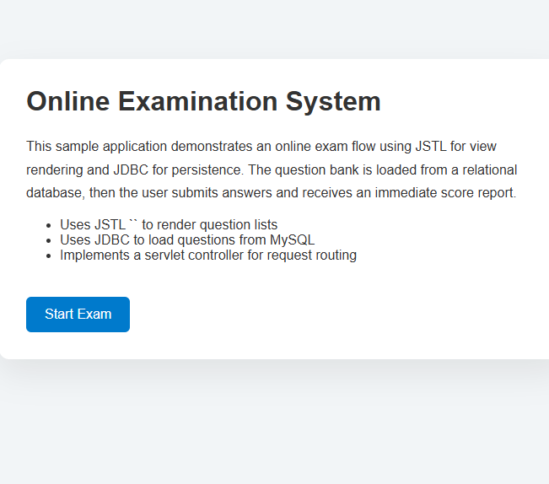

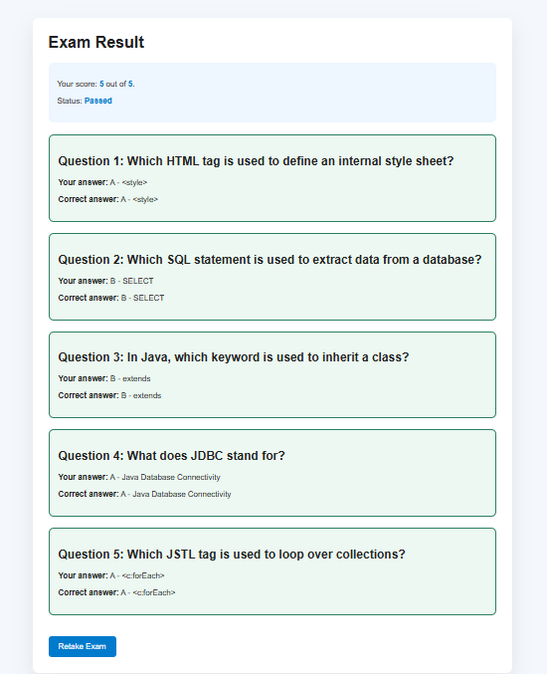

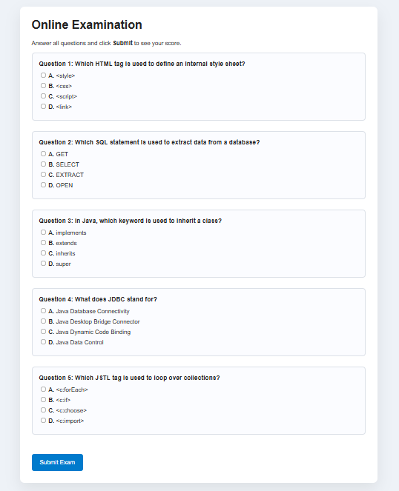

EXNO:9

package com.example.javabeans;

import java.awt.BorderLayout;
import java.awt.Color;
import java.awt.Dimension;
import java.beans.PropertyChangeListener;
import java.beans.PropertyChangeSupport;
import java.io.Serializable;
import javax.swing.JButton;
import javax.swing.JOptionPane;
import javax.swing.JPanel;
public class BeanComponent extends JPanel implements Serializable {
private static final long serialVersionUID = 1L;
private String buttonText = "Click Me Bean";
private Color buttonBackground = Color.CYAN;
private Color buttonForeground = Color.BLACK;
private Dimension beanSize = new Dimension(280, 120);
private final JButton button;
private transient PropertyChangeSupport propertyChangeSupport;
public BeanComponent() {
this("Click Me Bean");
}
public BeanComponent(String buttonText) {
this.buttonText = buttonText;
setLayout(new BorderLayout(10, 10));
button = new JButton(buttonText);
button.setBackground(buttonBackground);
button.setForeground(buttonForeground);
button.addActionListener(e -> JOptionPane.showMessageDialog(this, "JavaBean button clicked!"));
add(button, BorderLayout.CENTER);
setPreferredSize(beanSize);
propertyChangeSupport = new PropertyChangeSupport(this);
}
private void readObject(java.io.ObjectInputStream in) throws java.io.IOException, ClassNotFoundException {
in.defaultReadObject();
propertyChangeSupport = new PropertyChangeSupport(this);
}
public String getButtonText() {
return buttonText;
}
public void setButtonText(String buttonText) {
String old = this.buttonText;
this.buttonText = buttonText;
button.setText(buttonText);
propertyChangeSupport.firePropertyChange("buttonText", old, buttonText);
}
public Color getButtonBackground() {
return buttonBackground;
}
public void setButtonBackground(Color buttonBackground) {
Color old = this.buttonBackground;
this.buttonBackground = buttonBackground;
button.setBackground(buttonBackground);
propertyChangeSupport.firePropertyChange("buttonBackground", old, buttonBackground);
}
public Color getButtonForeground() {
return buttonForeground;
}
public void setButtonForeground(Color buttonForeground) {
Color old = this.buttonForeground;
this.buttonForeground = buttonForeground;
button.setForeground(buttonForeground);
propertyChangeSupport.firePropertyChange("buttonForeground", old, buttonForeground);
}
public Dimension getBeanSize() {
return beanSize;
}
public void setBeanSize(Dimension beanSize) {
Dimension old = this.beanSize;
this.beanSize = beanSize;
setPreferredSize(beanSize);
revalidate();
repaint();
propertyChangeSupport.firePropertyChange("beanSize", old, beanSize);
}

public void addPropertyChangeListener(PropertyChangeListener listener) {
propertyChangeSupport.addPropertyChangeListener(listener);
}
public void removePropertyChangeListener(PropertyChangeListener listener) {
propertyChangeSupport.removePropertyChangeListener(listener);
}
}

package com.example.javabeans;
import java.awt.BorderLayout;
import java.awt.Color;
import java.awt.GridLayout;
import javax.swing.JButton;
import javax.swing.JFrame;
import javax.swing.JLabel;
import javax.swing.JPanel;
import javax.swing.JTextField;
import javax.swing.SwingUtilities;
public class BeanDemo {
public static void main(String[] args) {
SwingUtilities.invokeLater(BeanDemo::createAndShowGUI);
}
private static void createAndShowGUI() {
JFrame frame = new JFrame("JavaBean GUI Component Demo");
frame.setDefaultCloseOperation(JFrame.EXIT_ON_CLOSE);
frame.setLayout(new BorderLayout(10, 10));
BeanComponent beanComponent = new BeanComponent("Hello Bean");
JPanel controls = new JPanel(new GridLayout(0, 2, 8, 8));
JTextField textField = new JTextField(beanComponent.getButtonText(), 15);
JButton updateText = new JButton("Update Text");
updateText.addActionListener(e -> beanComponent.setButtonText(textField.getText()));
JTextField bgField = new JTextField("#00CCCC", 10);
JButton updateBg = new JButton("Update Background");
updateBg.addActionListener(e -> beanComponent.setButtonBackground(parseColor(bgField.getText(), beanComponent.getButtonBackground())));
JTextField fgField = new JTextField("#000000", 10);
JButton updateFg = new JButton("Update Foreground");
updateFg.addActionListener(e -> beanComponent.setButtonForeground(parseColor(fgField.getText(), beanComponent.getButtonForeground())));

controls.add(new JLabel("Button text:"));
controls.add(textField);
controls.add(updateText);
controls.add(new JLabel());
controls.add(new JLabel("Background color:"));
controls.add(bgField);
controls.add(updateBg);
controls.add(new JLabel());
controls.add(new JLabel("Foreground color:"));
controls.add(fgField);
controls.add(updateFg);
controls.add(new JLabel());
frame.add(beanComponent, BorderLayout.CENTER);
frame.add(controls, BorderLayout.SOUTH);
frame.pack();
frame.setLocationRelativeTo(null);
frame.setVisible(true);
}
private static Color parseColor(String text, Color fallback) {
try {
return Color.decode(text.trim());
} catch (Exception e) {
return fallback;
}
}
}

OUTPUT:

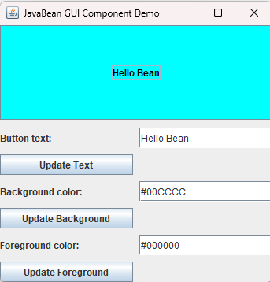

EXNO:10

import java.util.ArrayList;
import java.util.EventListener;
import java.util.EventObject;
import java.util.List;
public class EventSetBeanDemo {
public static void main(String[] args) {
MyBean bean = new MyBean();
bean.addMyBeanListener(event ->
System.out.println("Received event: " + event.getActionCommand())
);
bean.changeState("bean initialized");
bean.changeState("bean processed data");
}
}
class MyBean {
private final List<MyBeanListener> listeners = new ArrayList<>();
public void addMyBeanListener(MyBeanListener listener) {
if (listener != null) {
listeners.add(listener);
}
}
public void removeMyBeanListener(MyBeanListener listener) {
listeners.remove(listener);
}
public void changeState(String actionCommand) {
System.out.println("MyBean: state changed -> " + actionCommand);
fireMyBeanEvent(new MyBeanEvent(this, actionCommand));
}
protected void fireMyBeanEvent(MyBeanEvent event) {
for (MyBeanListener listener : new ArrayList<>(listeners)) {
listener.myBeanActionPerformed(event);
}
}
}
interface MyBeanListener extends EventListener {
void myBeanActionPerformed(MyBeanEvent event);
}
class MyBeanEvent extends EventObject {
private final String actionCommand;
public MyBeanEvent(Object source, String actionCommand) {
super(source);
this.actionCommand = actionCommand;
}
public String getActionCommand() {
return actionCommand;
}
}

